Paper No: 05-IAGT-1.3  Industrial Application of  Gas Turbines Committee | 

The TitanTM 130 Gas Turbine
Performance Uprate and Operating Experience

by

Mohammad Saadatmand

George Rocha

Brian Armstrong

of

Solar Turbines Incorporated
San Diego, California

ABSTRACT
Since its introduction in 1998 the Titan 130 gas turbine has undergone several uprates and now carries power ratings of 15.29 MW (20,500 hp) for the two-shaft mechanical drive version and 15.0 MWe for the single-shaft power generation version. As of this date, over 170 Titan engines have been sold and installed engines has accumulated well over 900,000 hours of operation. Most of the installed units have a Turbine Rotor Inlet Temperature (TRIT) of 1149°C (2100°F). The two-shaft fleet leader (high time unit) was removed from service as planned in October 2004 for its first major overhaul after 31,000 hours of operation. Based on fleet experience and continuous in-house development, Solar Turbines Incorporated has developed a thermal uprate for both the single and two shaft versions that increases power output, exhaust temperature as well as efficiency. This uprate requires only minor modifications to the hot section of the engine
This paper discusses the evolutionary design of the Titan 130 from the TaurusTM 70 and Mars® gas turbine products, the uprate history and field evaluation program of the two-shaft Titan 130 and general field experience of many engines in service.

INTRODUCTION
The Titan 130 industrial gas turbine was introduced by Solar Turbines Incorporated in 1998 in response to increasing application demands for higher performance industrial turbomachinery products in the 10 to 15 MW power range. The two-shaft version was introduced first, for gas compression and pump-drive applications. A single-shaft version, for power generation applications, followed in the year 2000. The products have been well received by users and, as of this date, over 170 Titan engines have been sold. Installed engines have accumulated over 900,000 hours of operation in both onshore and offshore applications in over 15 countries around the world.
Using Solar’s traditional development strategy of product evolution, the Titan 130 gas turbine design incorporates proven technology and design features for rugged, durable industrial service operation with minimal life-cycle costs. The gas turbine operating-cycle and overall aerodynamic design is similar to that of the 7.5-MW size class Taurus 70 introduced in 1995 (Rocha, 1995). Proven aerodynamic scaling techniques were implemented to establish flow path and airfoil component designs from the smaller Taurus 70 turbine. Thus, the basic design of the Titan 130 gas turbine features components directly scaled up from the Taurus 70 as well as hardware common to the 11 MW size class Mars gas turbine, see Figure 1. As with the Mars and Taurus 70 gas turbine products, the Titan 130 is available with either a conventional combustion system or a dry, lean-premixed, low pollutant emissions combustion system based on Solar’s SoLoNOxTM technology and demonstrated operating experience.
This paper discusses the evolutionary design of the Titan 130 from the Taurus 70 and Mars gas turbine products, engine uprates made since the original introduction, the field evaluation program of the two-shaft Titan 130 and general field experience.
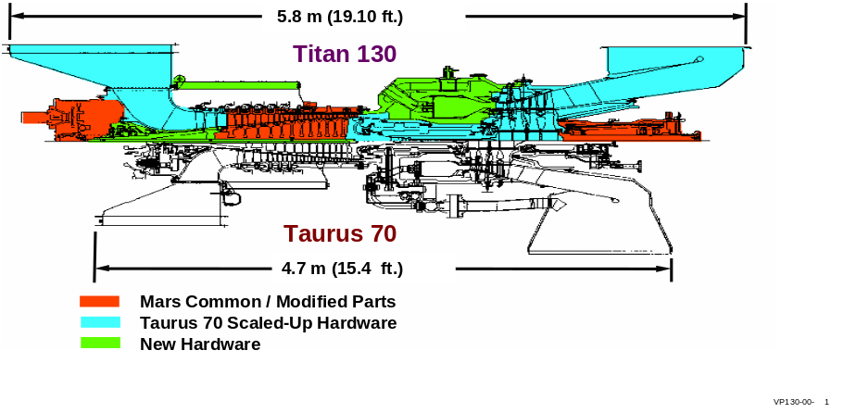Figure 1. Comparison of Titan 130 and Taurus 70 Two-Shaft Engines

DESIGN CONSIDERATIONS

Aerodynamic Scaling
Solar has successfully utilized aerodynamic scaling and zero-staging techniques to enhance and expand its gas turbine product line, while preserving the general design philosophy of product evolution from proven technology and operating experience. The use of an aerodynamically scaled flow path, with identical operating cycle parameters of pressure ratio and firing temperature, results in comparable gas temperatures and pressures throughout the compressor and turbine sections. The larger rotating and stationary components, while maintaining identical design features, cooling flows and delivery schemes, and reduced rotational speeds, have identical mechanical stress conditions at comparable metal temperatures. Implementing a gas turbine design strategy based on aerodynamic scaling accelerates the analytical process and reduces technical risks, as well as enabling the use of test results and operating experience gained from an existing proven gas turbine product.
Based on the exceptional aerodynamic performance and successful introduction of the Taurus 70 gas turbine in 1995 (Rocha, 1995), concept studies for the Titan 130 focused on selecting a similar operating cycle. Because of the aerodynamic similarity between the air compressors of the Taurus 70 and Mars engines, it was determined that the newly designed first or “00” stage of the Taurus 70 could be scaled up and added to Stages 1 through 13 of the Mars compressor. Similarly, the use of scaled-up versions of the well-proven Taurus 70 two-stage gas generator turbine and, for the single-shaft version, a newly designed third stage shrouded turbine, reduced product development risks on performance, cost and schedule.
Figure 2 provides a detailed look at the internal structure and key features of the two-shaft engine.

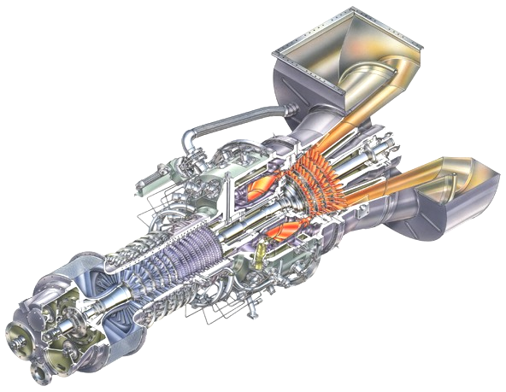
Figure 2. Cutaway Diagram of Titan 130 Two-Shaft Gas Turbine
ACCESSORY DRIVE
COMPRESSOR ROTOR
COMPRESSOR CASE
FUEL INJECTOR
COMPRESSOR DIFFUSER
BLEED AIR VALVE
NOZZLE CASE ASSEMBLY
EXHAUST COLLECTOR
EXHAUST DIFFUSER
OUTPUT DRIVE SHAFT
POWER TURBINE ROTOR
GAS GENERATOR TURBINE ROTOR
COMBUSTOR HOUSING
FUEL MANIFOLD
COMPRESSOR VARIABLE VANES
AIR INLET

Air Compressor
As noted, the air compressor section of the Titan was derived from both the Taurus 70 and Mars engines. The first stage is a direct scale up of the first or “00” stage of the Taurus 70. This is combined with the 13 stages of the Mars air compressor resulting in the 14-stage axial compressor design (Figure 3). Using the inverse of the scale factor, the rotor design speed for the larger Titan 130 air compressor was set at 11,220 rpm, compared to the Taurus 70 air compressor speed of 15,200 rpm, to match the original design speed of the Mars compressor rotor.
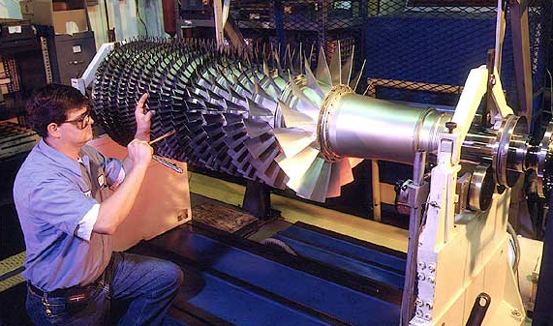
The scaled-up forward stage is characterized by a low aspect ratio, wide-chord airfoil design. This design, manufactured from forged materials, results in a robust compressor blade with ample mechanical strength for greater tolerance to ice ingestion in cold-ambient operating conditions. Self-aligning, curvic coupling-teeth are used to mate the forward bladed-disk assembly to a welded-drum rotor assembly from the Mars gas turbine stages 1 through 13. The Mars-derived compressor blades are manufactured from high strength, corrosion-resistant, nickel-based alloys using forged and investment cast processes. They have demonstrated component durability with millions of hours of service in demanding industrial operation. As with the Mars gas turbine, all compressor blades can be removed from the welded-drum rotor for cleaning or repair without major gas turbine disassembly. The entire rotor assembly, including a forward cone and aft-hub shaft, is held securely together with a solid centerbolt threaded into the aft-hub shaft and stretched with a centerbolt nut at the front end of the forward cone. The compressor rotor assembly features the trim-balance capability successfully demonstrated with the Taurus 70 rotor. Balance planes at the forward and aft ends of the rotor have been established and are accessible through ports in the housings to facilitate trim-balance correction of synchronous vibration levels in field service environments without disassembly.
Figure 3. Titan 130 Air Compressor Section
Similar to the Taurus 70 and Mars gas turbines, the vertically split case design allows ready access to flow path components for inspection, cleaning or service. Due to exit flow temperatures, a separate aft compressor case, manufactured from stainless steel and similar to that of the Mars gas turbine, is required. Both forward and aft cases feature dedicated borescope ports for internal inspection of blades and stators. A compressor bleed port is located on each side of the aft case for extraction of interstage bleed air from the eighth-stage for turbine cooling and seal buffering. The forward case, manufactured from cast ductile iron, contains variable geometry stator vanes as in the Mars compressor. Unison rings around the case actuate the variable vanes simultaneously via lever arms attached to each vane stem. The unison ring actuation system features an electromechanical linear actuator with a built-in position feedback for improved response and accuracy. Six rows of variable stator geometry help provide sufficient surge margin for the gas turbine during normal start-up. The compressor variable geometry stator vanes are also used at part-load operation in order improve emission levels.

Gas Producer Turbine
For the two-shaft version, the two-stage high-pressure turbine, or gas producer, driving the air compressor is scaled directly from the smaller Taurus 70 turbine with identical detail component designs, cooling schemes and material selections. Nozzle vanes and the first-stage turbine blades are internally cooled with compressor discharge air delivered internally within the gas turbine. The turbine cooling technology and design specifications were derived from the Mars gas turbine development and operating experience and verified through extensive component testing during the design phase of the Taurus 70 gas turbine.
All the turbine blades are investment cast from high strength, nickel-based superalloys. Protective diffusion-aluminide coatings for corrosion/oxidation resistance are applied to the first two stages. Cooling air for the first-stage blade and disk root attachments is supplied to the rotor by a first-stage diaphragm/preswirler delivery system. Forward and aft disk rim seals are used on the first-stage rotor to meter cooling airflow rates into the main gas path and minimize hot gas ingress along the inner hub region. The aft side of the second stage disk and the forward face of the third stage disk are cooled using the compressor bleed air delivered internally.
In the first and second stages of the turbine, the blades have under-platform friction dampers/seals between adjacent blades to dissipate vibration energy and to seal hot gases from the blade root attachments. An important tip-clearance control feature, demonstrated with the Taurus 70 design, allows tight tip clearances to be set and maintained through transient and steady-state operation, including hot restart conditions. Independent nozzle support rings for each turbine stage have been sized to match the thermal response of the rotor disks during transients. This design characteristic, and use of blade tip seals faced with abradable coating, minimizes occurrences of tip rubs, ensuring optimum output performance. The module design configuration enables the turbine disk and nozzle support ring assemblies to be removed from the gas generator horizontally as a bundle with proper field tooling. Removal of the turbine bundle and diaphragm/preswirler assembly enables access to the combustor liner for inspection and/or repair in field service environments.

Power Turbine
The power turbine module in the two-shaft engine is a direct scale-up of the Taurus 70 power turbine assembly, featuring a two-stage axial turbine design, delivering the output power across a broad operating speed range. The independent module is flange mounted to the aft end of the gas generator module turbine housing in a close-coupled arrangement. The two modules can be separated in the horizontal position requiring less than 50 mm (2 in.) of axial disengagement distance for lateral clearance between modules. This minimal disengagement distance between modules facilitates removal and replacement of either module assembly from either side of the turbomachinery package skid. Two tilting-pad journal bearings support the power turbine rotor in an overhung arrangement with a tilt-pad thrust bearing located at the output end of the rotor shaft. An enhanced version of the Mars power turbine bearing housing has been adapted to the Titan 130 power turbine module. The exhaust collector redirects exhaust flow radially outward and can be rotated in various circumferential orientations to accommodate installation requirements. An interconnect-shaft system with a dry, flex-type coupling is used to couple the power turbine rotor shaft to the driven equipment.
For the Titan single-shaft configuration, the power turbine module is removed and a new third-stage turbine, directly scaled from the Taurus 70 single-shaft, is bolted to the two-stage gas producer turbine. The three disks are assembled via curvic coupling interface with high strength through-bolts for increased clamp load and torque capacity. The third-stage blade is shrouded for better tip clearance control and blade vibration damping. The third-stage nozzle assembly also provides the structural support for the axial discharge cast exhaust diffuser. Thus the axial diffuser is designed and sized for optimum aero-performance recovery with minimal losses. The two diverging inner and outer walls of the exhaust diffuser are held together through one set of airfoil shaped struts. Compensation for the engine’s axial thermal expansion and contraction is provided by a flexible bellows. All three individual nozzle support ring assemblies can be installed and removed in modular form to simplify gas turbine assembly and disassembly.

Rotor Bearings and Seal System
Similar to the Taurus 70 and Mars gas turbines, the Titan 130 turbine rotor is supported by three identical tilt-pad journal bearings, designed with the latest fluid-film bearing technology, for stable rotordynamic operation. The physically larger journal bearings have a length-to-diameter ratio greater than that of the Mars to provide additional damping and to enhance rotordynamic stability through all modes of operation. As is typical with larger gas turbines, rotor shaft displacements and vibration characteristics are monitored during operation by two proximity probes mounted at each journal bearing location to ensure that acceptable levels are maintained and to initiate gas turbine shutdown when limits are exceeded. The thrust bearing is located at the front end of the gas turbine adjacent to the front (No. 1) journal bearing in the compressor. The thrust bearing assembly consists of self-aligning, tilt-pad type bearings on the forward, active-side with a fixed, tapered-land bearing on the aft, inactive side. Bearing protection and temperature monitoring are provided by two temperature sensors embedded into pads on the loaded side of each thrust bearing. Axial proximity probes installed in each thrust bearing assembly to monitor rotor axial motion also are available as a standard package option. As in the Taurus 70 and Mars gas turbines, location of the thrust bearings in the Titan 130 gas turbine provides easy access by field service personnel for inspection and service without major component disassembly or gas turbine removal.

Combustion System
The Titan 130 gas turbine was introduced with a dry, low emissions combustion system based on Solar’s proven SoLoNOx pollution-prevention combustion technology. Operating on gas fuel, the dry, lean-premixed combustor is capable of reducing nitrous oxides (NOx) and carbon monoxide (CO) pollutant emissions to levels down to 15 ppmv and 25 ppmv, respectively, over a wide load range.
Figure 4. Titan 130 SoLoNOx Combustor with Case Bleed
The in-line, annular combustor is situated between the compressor and turbine assemblies within the gas generator module (Figure 4). The combustion system features 14 lean-premixed gas or dual fuel injectors similar in design to the Mars 100 and Taurus 70 injectors, and a combustor liner with advanced impingement/effusion cooling technology.
A diffusion-flame, conventional combustor is also available and has been integrated into the gas generator module with no changes in rotor shaft or overall engine length relative to the SoLoNOx version (Figure 5). Maintaining Solar’s philosophy of product evolution from proven designs, the Titan conventional combustion system has been adapted from the Mars conventional combustion system by incorporating identical fuel injectors, ignition torch and modified combustor. Twenty-one fuel injectors are mounted in the same Mars arrangement and engage the same Mars dome assembly of the combustor liner. Combustor liner outer and inner wall exit panels were modified to match the inlet diameter geometry of the larger Titan flow path. Cooling scheme enhancements were implemented based on factory development testing and Mars operating experience to optimize combustor performance and liner metal temperature patterns. With common fuel injectors, the Titan 130 can operate on a wide range of gaseous and liquid fuels.
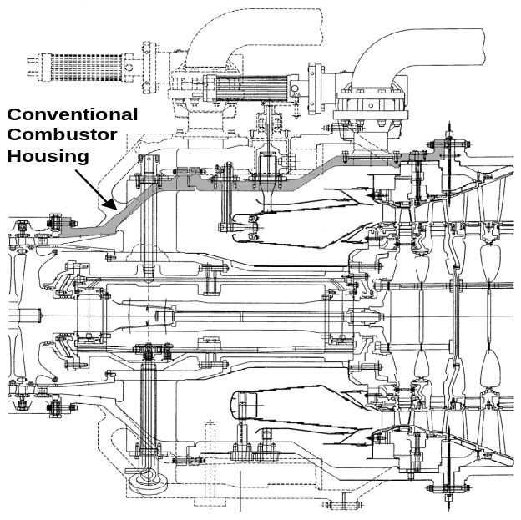Figure 5. Overlay of Titan 130 Conventional and SoLoNOx Combustors

Exhaust Options
The single shaft version of the Titan is now available with either the standard axial exhaust diffuser or a radial exhaust collector. The radial design can be of benefit to users in applications where floor space is limited, such as on offshore platforms. The exhaust ducting and silencers can be arranged to minimize the footprint of the overall turbomachinery package.

PACKAGE SYSTEMS
As with other Solar® gas turbines, the Titan is usually shipped as part of a complete turbomachinery package where the turbine is the driver for a generator, gas compressor or pump. The package contains all the sub-systems necessary for operation including start, fuel and lubrication. A control system sequences and monitors all functions including those of the driven equipment.
Overall package size depends on the driven equipment. A typical unenclosed generator set package (single-shaft turbine) is 14.2 m (46’ 6”) long, 3.5 m (11’ 6”) wide, and 3.3 m (10’ 10”) high. The base frame is constructed using I-beams with a ladder-type design. The driver and driven equipment are on individual base frames that are bolted together but can be separated for flexibility in shipping.
The lubrication system circulates oil under pressure to the gas turbine and driven equipment. The lube oil tank is integrated into the driver frame. The system includes filters, strainers, pressure and temperature regulators, and oil level, pressure and temperature indication. Pre and post lube pumps ensure adequate oil circulation before start up and after shutdown to protect equipment bearings. A battery powered backup post lube pump provides post lube in the event AC power is interrupted.
The fuel system, in conjunction with the control system, includes all necessary components to control ignition and fuel flow during all modes of operation. Four standard fuel system configurations are available: SoLoNOX gas fuel, conventional gas fuel, SoLoNOx dual fuel (gas and liquid) and conventional dual fuel. High force electrically actuated gas fuel valves provide precise fuel control with position feedback.
The start system consists of two direct-drive AC starter motors driven by a common solid-state variable frequency drive. The system provides torque to initiate engine rotation and accelerate the engine to self-sustaining speed.
The package includes Solar’s comprehensive TurbotronicTM control system that provides control, monitoring and data collection for the package. In the standard configuration, all key control components are installed on the package skid permitting full operator control at the skid-edge. This is of benefit during commissioning and service. The control system internal network can be extended to other locations such as a control room for routine equipment operation and monitoring. Serial links to customers’ supervisory systems can transmit both real-time operating data and historical data files.
In addition to controlling the turbine, the system also controls the driven equipment and can provide a range of functions. For generator sets these include: synchronization, kilowatt, kVAR and power factor control, plus load sharing, and import and export control. For driven compressor packages, available functions include process control and compressor anti-surge control. Controls scope can be expanded to cover other balance of plant equipment.
The Titan 130 package can be supplied unenclosed, with a driver-only enclosure, or with a full package enclosure. Trolley rails are provided for internal equipment removal and handling. Engine removal is accomplished by an external structure and gantry crane off-skid.

UPRATES
When first introduced in 1998 the two-shaft had a power rating of 13.3 MW (17,800 hp), a firing temperature of 1121°C (2050°F), and an efficiency of 34.5%. The single-shaft engine for power generation, introduced in early 2000, had a 12.8 MWe rating (measured at the generator terminals) and an efficiency of 33.0% (Saadatmand 1999). In late 2000, the materials of the first and second stage of the power turbine were upgraded. This change enabled the firing temperature to be increased to 1149°C (2100°F) and this increased the power ratings to 14.5 MW (19,500 hp) for the two-shaft and 14.3 MWe for the single-shaft models. The efficiencies increased to 35.7% and 35.0% respectively. In 2004, a modification to the third stage nozzle in the power turbine of the two-shaft engine permitted a modest increase in power to 14.8 MW (19,850 hp) with a corresponding increase in efficiency to 36.0%.
This year additional modifications are being implemented in the turbine section that will be effective on shipments starting in 2006. These changes result from a detailed study of the entire hot section of the turbine using state of the art temperature measurement techniques and involve subtle changes to the cooling mechanisms. The three key changes are: first, using a technique referred to as “jump cooling”, a small amount of cooling flow is injected just upstream of the leading edge of the first stage nozzle; next, new core dies have been developed for the first stage rotor blades and the second stage nozzle that change the internal cooling geometry slightly; and finally, the casting and material for the second stage rotor blades is being changed. Together, these modifications permit the firing temperature to be increased to 1177°C (2150°F) with resulting increases in power and efficiency to 15.3 MW (20,500 hp) and 36.2% for the two-shaft and 15.0 MWe and 35.2% for the single-shaft designs.
Tables 1 and 2 summarize the uprate history for the two models of the Titan 130.
Table 1. Titan Two-Shaft Uprate History
 |  | 1998 | 2000 | 2004 | 2006
Power | KW | 13 280 | 14 550 | 14 800 | 15 290
Power | hp | 17,800 | 19,500 | 19,850 | 20,500
Efficiency | % | 34.5 | 35.7 | 36.0 | 36.2
TRIT¹ | °C | 1121 | 1149 | 1149 | 1177
TRIT¹ | °F | 2050 | 2100 | 2100 | 2150
Table 2. Titan Single-Shaft Uprate History
 |  | 1999 | 2000 | 2006
Power | KWe² | 12 800 | 14 250 | 15 000
Efficiency | %² | 33.3 | 35.0 | 35.2
TRIT¹ | °C | 1121 | 1149 | 1177
TRIT¹ | °F | 2050 | 2100 | 2150

- Turbine Rotor Inlet Temperature
- Power and Efficiency at Generator Terminals

OPERATING EXPERIENCE
The total operating experience of the Titan 130 is now in excess of 900,000 hours. Only a few units were shipped with the introductory firing temperature of 1121°C (2050°F), so the vast majority of the installed units and hence the operating experience is with the 1149°C (2100°F) design.

Field Evaluation Program
In order the monitor early field performance a cooperative test program was set up with one customer. The turbine served as a driver for a third party gas compressor in a pipeline application (Figure 6). This was a formal program with clearly specified inspection requirements and intervals during the first 8000 hours of operation. To minimize the impact on the customer’s operations, special arrangements were made to have spare parts and an exchange engine readily available. Table 3 summarizes the planned and unplanned events throughout the program.
Table 3. Field Evaluation Program
Date | Event | Comments
May 98 | Shipped MD Package | Met Site Construction Schedule
Sep 98 | Started Commissioning | High Vibrations with Driven equipment.
Nov 98 | Gas Compressor Bearing Modifications | Marginal Improvement; Combustor Liner Inspected;  Redesigned Gas Compressor Bearing Proposed
Feb 99 | Gas Compressor Repaired | New Gas Compressor Bearings Installed
Mar 99 | Completed Commissioning
July 99 | 2000-hour Inspection | “Excellent Condition”; Improved Bleed Duct
Aug 99 | Gas Compressor Repaired | Dry-Gas Seal Failure @ 2400 hours
Sep 99 | 3000-hour Inspection | “Excellent Condition”; Variable Guide Vane Seal Clearance Increased; Single Actuator Configuration
Nov 99 | Power Turbine Change-out | Drive-Train Vibration Instability @ 3600 hours. Retest Normal
Feb 00 | 5000-hour Inspection | “Good Condition”; 100% Availability; Interconnect Shaft Replacement
Apr 00 | 7000-hour Inspection | “Good Condition”; 100% Availability
Jun 00 | 8000-hour Inspection | “Good Condition”; 100% Availability; Program Successfully Completed

The 8000-hour evaluation period began once commissioning was complete and the unit placed in continuous commercial service. Initial delays in commissioning were attributed to operational issues with the vendor-supplied gas compressor. High rotor vibrations and high temperatures at the journal bearing under certain operating load conditions limited the operational range of the gas compressor. Troubleshooting efforts by the vendor ultimately led to a complete redesign and replacement of a journal bearing, which resolved the operational problem. In the early hours of operating experience, minor adjustments were required to fine tune the operation of the package hydro-mechanical systems and the control system display software. Operational data and feedback from customer operators and Solar's Field Service personnel were used to make adjustments to package components, wiring connections, controls system logic and display software parameters. A continuous emissions monitoring system (CEMS) supplied by Solar with exhaust-stack sensors provided real-time combustor emissions data used to fine tune controls system logic and algorithms to maintain NOx and CO emissions below the guaranteed levels at all ambient operating conditions.
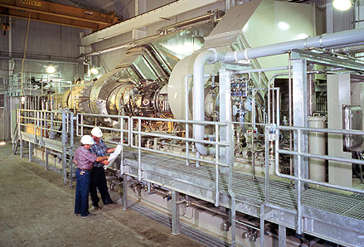
Figure 6. Titan 130 Field Evaluation Installation
At the 500-hour engine inspection, the heat-tint patterns on relatively clean metal surfaces of the turbine airfoils were reviewed and correlated to temperature exposure during operation. Tint patterns and flow path blade tip rub conditions were noted and provided a baseline condition for the gas turbine for future comparison. At the 2000-hour inspection interval, an improved bleed duct was installed with modifications to the inlet port of the exhaust collector. Upgrades were based on recent design improvements made on the Mars bleed duct system. An unexpected failure of the dry-gas seal system in the gas compressor, which occurred after 2400-hours of operation, was successfully repaired in the field by the manufacturer.

High Time Engine
Last October, the engine that was the subject of the field evaluation program and was also the high time engine, with a total of 31,000 hours, was taken out of service as part of a planned overhaul and exchange and brought to Solar’s Engine Overhaul facility in Texas. As might be expected, this unit was the object of a very detailed analysis while it was being disassembled as part of the overhaul process.
In general, the turbine was in very good condition given its hours of operation and, in the opinion of the engineers and service experts doing the examination, could have been run to at least 40,000 hours before overhaul. There were the expected wear features such as light contamination or corrosion on some surfaces and evidence of tip rub in some locations. Bearing pads showed light wear, well within the expected range. The fuel injectors were in generally good condition with some carbon deposits on the tips. In the power turbine section, the first stage tip shoes several cracks were observed. This unit was the original design with 18 first stage tip shoes. This design was subsequently changed to 27 tip shoes to reduce warping and cracking. This modification was applied to all engines starting in 2001.

General
Two issues that did emerge with some of the earliest engines involved the second stage diaphragm and the first stage compressor blade designs. The grain structure and protective coating of the diaphragm were judged to be inferior. The blade was determined to be marginal in terms of its alternating stress capability. For the diaphragm, new forging dies were developed that improved the grain structure and a new coating process achieved the required thickness. For the blade, a redesign and material change provided an improved stress margin. In addition to incorporating these changes into new production engines, a field upgrade program was initiated that has resulted in the retrofitting of all the field units.

SUMMARY
Since its recent introduction, the Titan 130 industrial gas turbine has gained market acceptance with more than 170 combined two-shaft and single-shaft units sold. The Titan 130 two-shaft is rated at 20,500 hp with 36.2% efficiency and its single shaft configuration is rated at 15.0 MWe with 35.2% at ISO operating conditions.
Developed based on Solar’s traditional design philosophy of product evolution from proven technology, the Titan 130 is an aerodynamic scale of the smaller Taurus 70 gas turbine. It features similar operating cycle parameters, scaled turbine components and a modified version of the Mars air compressor. The use of scaled and common hardware from previously proven Solar products has provided a low-risk design that has shown itself well-suited to rugged and reliable operation in industrial applications. The gas turbine has been thoroughly tested both in development and through field operation to verify output performance and mechanical integrity at all expected operating conditions. Product durability has been demonstrated with the high time engine successfully reaching its first scheduled overhaul point with fully satisfactory performance. The soundness of the original design has also been confirmed with by the fact that several uprates have been completed through relatively minor design modifications.

REFERENCES
Rocha, G, Saadatmand, M.R., Bolander, G., 1995, “Development Of The Taurus 70 Industrial Gas Turbine”, ASME Paper 95-GT-411, Houston, Texas.
Saadatmand, M. R., Rocha, G., 1999, Design and Development of the Solar Turbines Single Shaft Titan 130 Industrial Gas Turbine” Power Gen Europe 1999.
Rocha, G. and Rainer Kurz, “ Field And Application Experience Of The
Titan 130 Industrial Gas Turbine” ASME Paper 2001-GT-0224

